Step 1 – Install OpenVPN
- On the PC that you will be using to access the server download the .exe fie from this link:
https://sync.vmcloud.ca/shares/file/Rx8MNACOYuK/
- Run the .exe 
- In the pop up that appears click on “More info” link 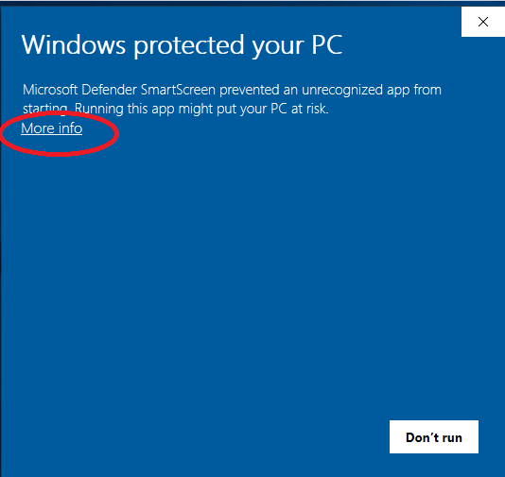
- Then click on 
- Go through the steps of installation
- After it installs the OpenVPN GUI you will be prompted to install the OpenVPN Installer
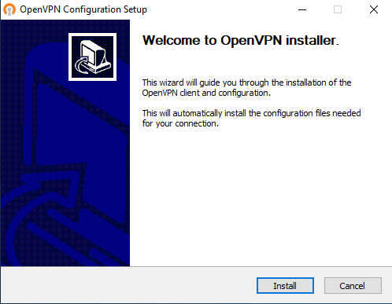
  - Click on Install and follow the steps until this is fully installed on your PC

Step 2 – Connect to OpenVPN
- In the taskbar of your PC will be the OpenVPN icon
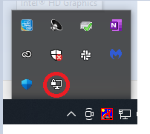
- Right click on this icon and then click on “Connect”
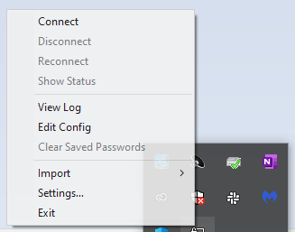
- Enter your unique OpenVPN user name and password assigned to you
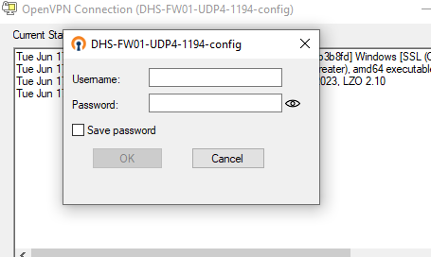
- Once successfully connected in the task bar icon will show as connected 

Step 3 – FTP
- Now that you are connected to the server by OpenVPN proceed to your FTP client per usual
- In your FTP client everything will be the same and if required to enter a server IP enter the old server address 51.161.50.130
  - Even though new server IP is different still use 51.161.50.130 as the server IP as this is a tunnel IP address
- FTP user name and password are the same as previously
- After completed your work on the server disconnect from OpenVPN. Do so by right clicking on the OpenVPN icon in the taskbar and then click on Disconnect 